Risks & Mitigations
  - IT Project Delivery

Synopsis
The success of a programme/project which contains an IT element depends on the timely delivery of deliverables expected and usable by different stakeholder groups.
These expectations are unlikely to be met without a clear idea of what risks are common to IT projects, so as to avoid them.
This document lists and explains common IT Project risks to recognise and avoid.

Author
Sky Sigal, Solution Architect, ITC SPA

Document

Table of Contents
Synopsis i
1 Document 2
Table of Contents 1
1.1 Description 1
1.2 Distribution 2
1.3 Conventions 2
2 Context 3
2.1 Background 3
2.2 Objective 3
2.3 Scope 3
2.4 Applicability 3
3 Risks 4
3.1 Planning Duration 4
3.2 Planning Phases 5
3.3 Duration Tooling 5
3.4 Stakeholder SMEs Engagement for Discovery 7
3.5 Delivery SMEs Roles 9
3.6 Methodology 9
3.7 Deliverables 10
3.8 Key Delivery Service 11
3.9 Requirement Development 12
3.10 System Design 15
3.11 Logical Ordering of System Component Development 18
3.12 Costly Logical Errors 20
3.13 Effort Estimations 20
3.14 Delivery Team Interactions 21
3.15 Defect Catching 23
3.16 Full Regression Testing 24
3.17 Capabilities 24
3.18 Conclusion 24
4 Appendices 25
4.1 Glossary 25

Creation
Date: 18/05/2021

Distribution
Distribution/Review List:
- Amy Orr, Data Architect
- Brad Atte Le Crouche, Solution Architect
- Diane Simpson, Infrastructure Architect
- Michelle Nicolson,
- Dries Venter, Cloud Infrastructure Specialist
- Grayson Mitchell, Manager, BE&S ICT SPA
- Jeff Grove, Security Specialist, Contractor
- Sally Murrey, ICT Change Advisor
- Sean Torley, ICT Change & Transition
- Stuart McGrigor, Solution Architect
- Werner Van der Merwe, Automation Lead
- Yujia Huang, Security Specialist, Contractor

Conventions

Terms
The Appendices include a Glossary of Terms to assist understand this document.

Diagrams
Where applicable, diagrams are developed using ISO-*, Archimate, UML or appropriate industry standards and conventions.

Context

Background
IT Project Delivery Management is a specialised subtype of general Project Management, with a distinct set of risks to consider.
Market scarcity leads to a relatively common condition where IT projects are being delivered via generalist project managers with limited prior exposure to successful IT delivery processes.

Problem
Delivery Managers are reliant on a reactive, ad hoc, process of incomplete discovery of expected deliverables and risks – rather than having a clear understanding of objectives, expected deliverables, planned processes to deliver them and common avoidable risks to avoid.
This leads to unnecessary remedial costs, while significantly increasing the risk of the project failing to deliver some or all the expected deliverables within budget and/or schedule.

Objective
The purpose of this document is to provide stakeholders a list of common risks endemic to the industry to plan around from the start of a project.

Scope
The scope of this document includes describing the delivery Risks to consider avoiding.
It is not within this document’s scope to describe what to deliver, nor how to deliver them according to ISO recommended delivery methodologies.

Applicability
Any project that has an IT component.

Risks
The following is a list of common Risks categories associated to project delivery that can be mitigated.

RFP Stage
Risks are built into early, at the RFP definition stage.
Key risks include:
- Not collecting the Desires of a wider set of stakeholders beyond current business stakeholders.
This omission of research produces RFP’s Requirements omitting those needed by other stakeholders required to fulfill their roles of Supporting, Operating, Maintaining, incrementally Improving the business service over its full service lifespan. In turn, the system procured will be imcomplete, requiring additional expense to work around its inadequacies. Common omissions of capability that constrain use and/or require changes of behaviour to workaround the system include:
  - Identitification of users is limited to a subset of possible users (eg: organisation users), severely limiting or even removing the ability to collaborate with contributors, consultants, partners or even reach potential customers.
  - Provisioning users is unable to be automated, causing a bottleneck due to requiring support or operations staff to onboard users
  - Terms and Contracts are not provided -- or at best are system-wide -- requiring out-of-system workflows to contractually bind end users to acceptable behaviour and responsibilities.
  - Notification is not provided, whether in-system or by integration, requiring effort
  - System Delivery
    - The RFP requirements specifies the deliverable as the business Service, and not the automation of the delivery of the Service.
    - The RFP Requirements do not specify that organisation resources be used to manage the project, so IP associated to project improvement and delivery is difficult to retain beyond the initial delivery phase.
  - System Security
    - The RFP Requirements do not clarify the difference between short-term diagnostics logging and permanent auditing, putting the organisation at risk for not complying to legal auditing obligations.
    - The RFP Requirement
  - System Operations
    - The RFP Requirements does not provide an authorisation mechanism mature enough to handle current needs and business growth.
  - System Maintenance
    - The RFP Requirements may only specify monitoring, and omits requing automated self-correction, or even alerting capabilities, therefore committing the system to frailty and/or costly Maintenance FTPs to monitor the system for abnormal behavior.

Contractual Stage
Risks continue to be built into projects early, in the post RFP contractual definition stage.
Contracts often do not include mitigations of the following relatively common issues:
- Confusing procurement policies to buy before build, at the expense of delivering stakeholder desired capabilities and qualities.
  - Examples include purchasing internal enterprise software, even if well known, for customer facing conditions.
- Decrease control, engagement & responsibility to delivering outcomes
- Decrease control over supporting deliverables
- Increase lock-in and expenses
- Incorrectly focus on describing the engagement experience and system features, rather than the outcome’s purpose and capabilities
- Focus on delivering the wrong service
- Environments. 20 years ago, the number of common environments required were at the very least were System Testing (ST) for QA purposes, UAT for Stakeholder User Engagement and Feedback, TRAINing for holding Data, PrePROD, PROD. For services, the minimum list of environments would include the
While mature contracts may ensure Capabilities are delivered within Frameworks to specific Qualities, it is still relatively uncommon for Contracts to be develop controls to ensure a flexible and evolving collaboration of vendor(s) is possible, using common services provided and managed by the project owner’s organisation, throughout the service development and operations lifespan.

IP, Infrastructure and Service Lockin
Vendor providers have vested licenses, subscriptions and experience in their use which they can offer to leverage to diminish early costs and start up delays.
The long-term impacts of agreeing to these decisions outweigh their short-term benefits.

Vendor lockin of project IP
When feedback and tasks are managed within systems and services provided by vendors, vendor lockin of the IP ensues. The recorded feedback, analysis, tasks, and history become difficult -- at any expense -- to migrate to an alternate organisation managed solution later.
The impacts are several:
- Decreased Delivery Quality: the cost and difficulty to migrate IP impacts the resolve to seek better outcomes elsewhere. When IP is managed outside of an organisation, product ownership often gets split, or even transferred along with it, leading to an uncertainty as to whom is driving delivery.
- Decreased Product Quality: when a business service’s maintenance becomes the responsibility of a organisation other than the business service provider, it's importance is impacted, in two ways. The objective is lost as it becomes the service contract, not the business service. The appetite for iterative improvement based on feedback is hampered, as change is not perceived as an opportunity, but instead perceived as effort and risk, to the vendor.
- Decreased involvment: when another organisation manages issues, along with cross-organisation communications barriers, in turn lowers organisation involvement by other team members. This risk is not mitigatable by solely governance or delivery management frameworks.
- Decreased Support Quality: migration of the IP required to operate, maintain and iteratively improve the service remains difficult to implement.
- Increased Support Costs:, the lack of sufficient information to support, operate, maintain, iteratively improve or even decommission the service in turn leads to an ongoing inappropriate reliance on the vendor, with contractual and cost ramifications.

Infrastructure and Service Cost Lockin
Vendor are naturally inclined to using their own familiar infrastructure or subscriptions to decrease response time and increase project profit.
This risk must be managed at the contractual level as this has multiple impacts:
- Decreased security: although projects start with no data, projects at some point invariably require organisation data to be shipped outside the organisation to the vendor’s environments for testing, analysis, testing. Organisation data outside of an organisation cannot be secured.

Planning Duration

MVP Based Duration Planning
A risk to projects is under-estimating the duration of time that requires planning, and therefore underestimating the number of phases and tasks that need resolving.
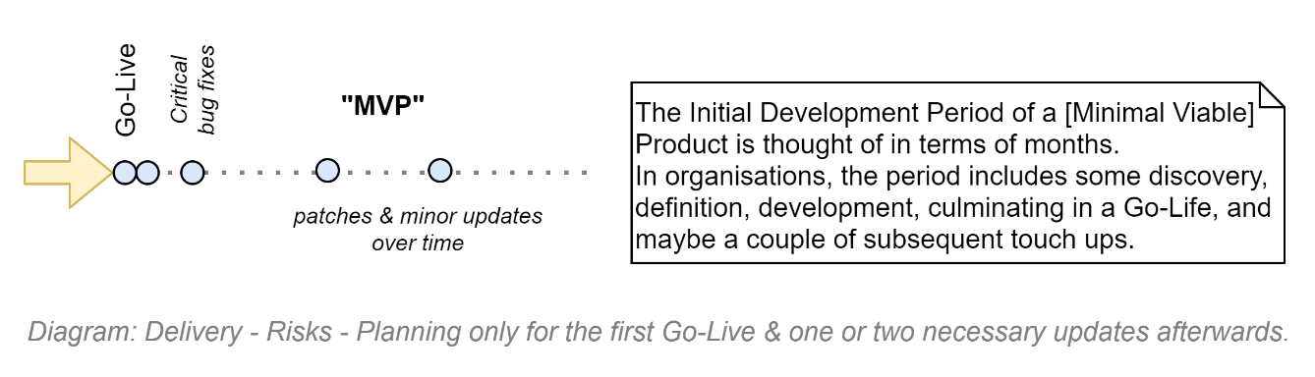
It is common for project delivery to concentrate planning on Discovery, Definition, Development so as to get to an initial “Go-Live” Deployment.
And although there is a general acceptance that the initial Go-Live will rarely be the last deployment -- a couple more deployments may be needed to iron out critical errors and medium kinks – only cursory attention is spent on what happens next.
The result is s that projects under-estimate the duration of time that must be planned for: the whole service lifecycle over which many more deployments will occur, change management is required and monitoring, maintenance, operations and support will be offered.
In general terms, it’s thinking of developing a Product, throwing other ongoing issues “over the fence”.

MVS Based Duration Planning
More complete planning is achieved by planning for delivering an ongoing Service, as opposed to a Product.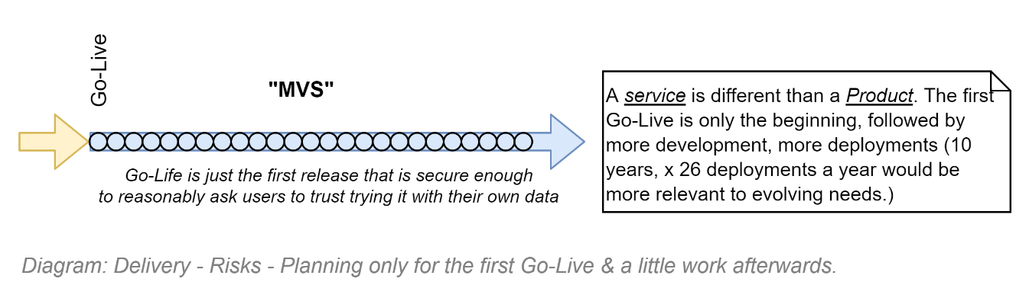
Services require planning of ongoing improvement, re-deployment, monitoring, maintenance, operations, support.
Services doesn’t think much of the initial Go-Live release and instead sees it as only the first of an average of 26 releases per year, every 2 weeks, for as long as the service is of value.

Planning Phases
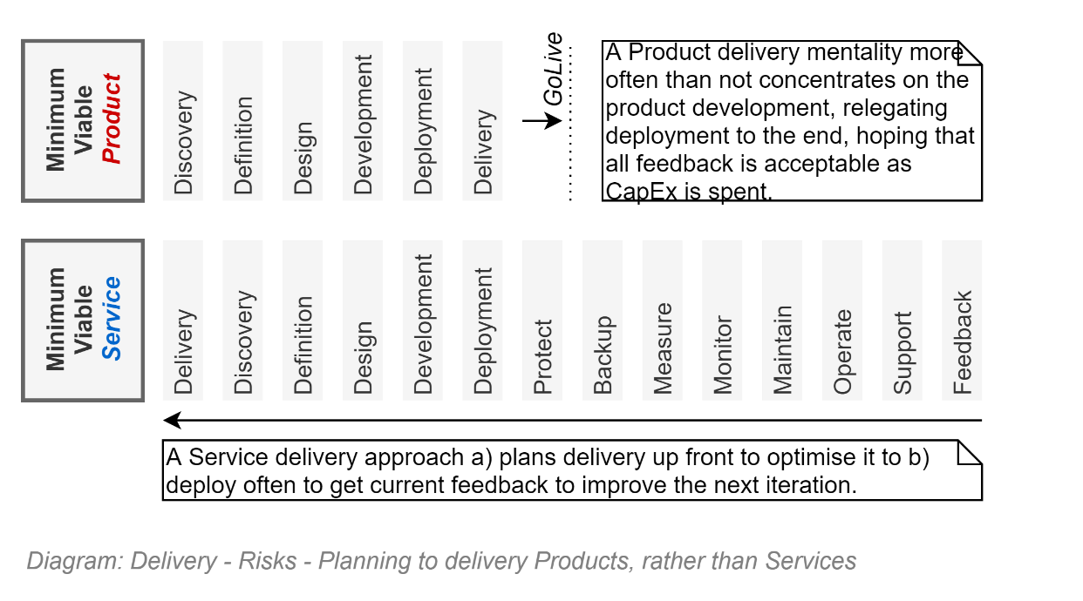

Duration Tooling
A risk to projects is underestimating the amount of tooling required to start a maintainable project.
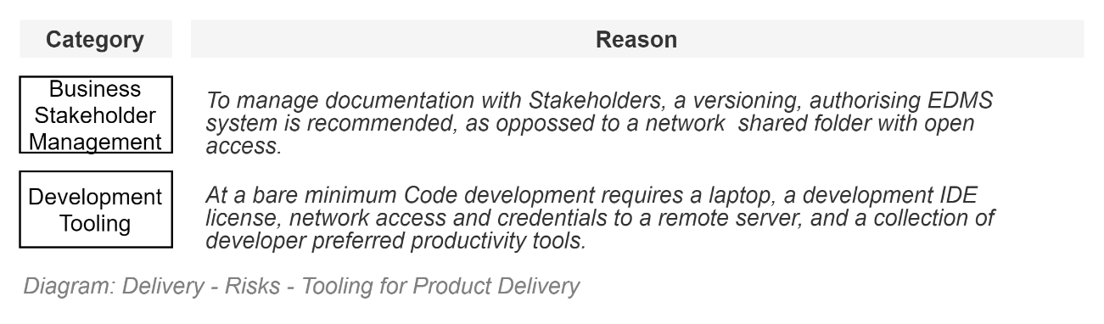

Individual Based Development
On a personal basis, for personal development, or a throw away PoC, little is needed, hence the persistent IT industry impression that all one needs is a laptop and some local tools to get going, with some backing from a central place to persist guidance and findings.

Team Based Development
When working in teams though the emphasis of tools required shifts towards adding efficiently to inter-person and inter-group communication, delivery and preparation for ongoing service operations.
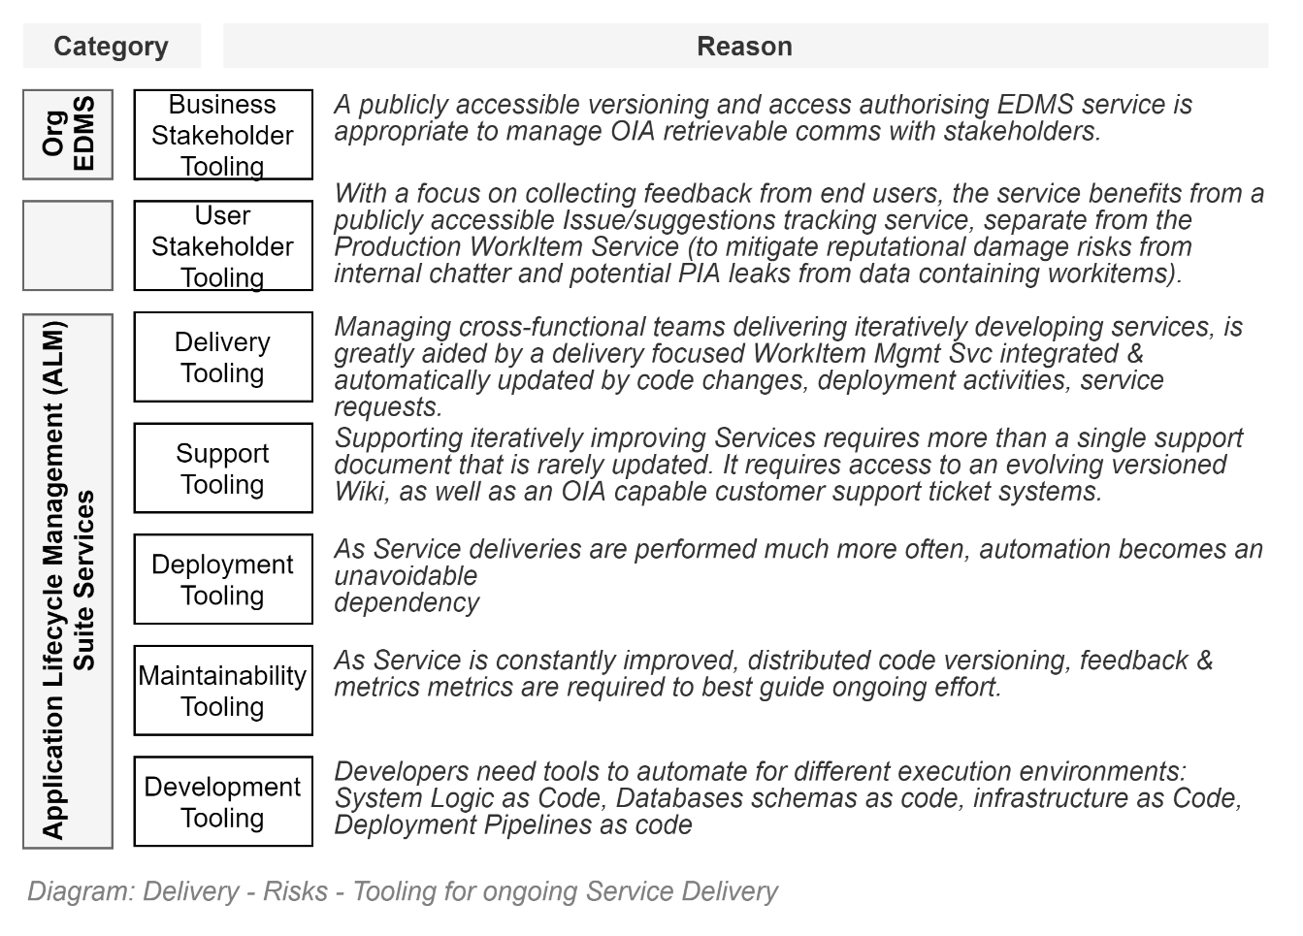

Tooling Suites
A risk to projects is starting development without the right tooling and processes, because the tools take too long to configure and integrate.
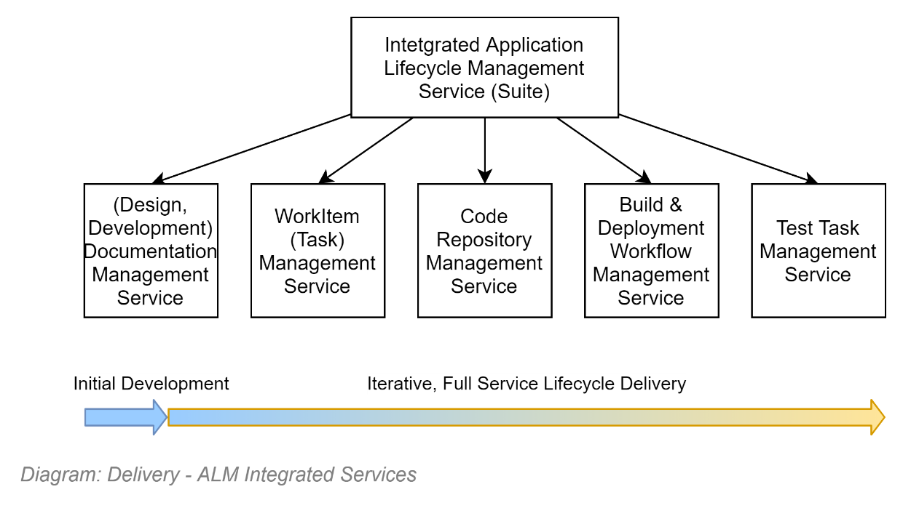

Separate Delivery Tooling Services
Over the past decade COTS and SaaS services have been developed to address each of the above common delivery service needs.
Examples include using Confluence for Documentation management, GitHub for Code Management, JIRA shoe-horned into performing work item management and testing management.
These services, having been built by different vendors over time, some being Cloud services, some intended to be installed onPrem, each with different security and general installation requirements requirements, productive integration is onerous -- if even achievable.

Application Lifecycle Management Suite
To avoid the cost and delay of configuring multiple tools at the start of a project, current best practice is to develop a Project Space within a SaaS based Application Lifecycle Management (ALM) Service to provide a unified suite of useful development, delivery & operations services.
Using an organisation provided ALM has distinct advantages, including:
- Already integrated, removing the length time to configure it as needed
- Faster to obtain,
- Licensing is already sorted,
- The organisation will have a list of pre-approved widgets and tools that can enhance productivity and understanding (e.g.: pre-made Task Velocity Dashboard widgets, etc.)

Stakeholder SMEs Engagement for Discovery
A key risk of the project is the engagement of a Business Analyst (or worse -- no BA) to convert the Desires of Stakeholder SMEs into Defined requirements.
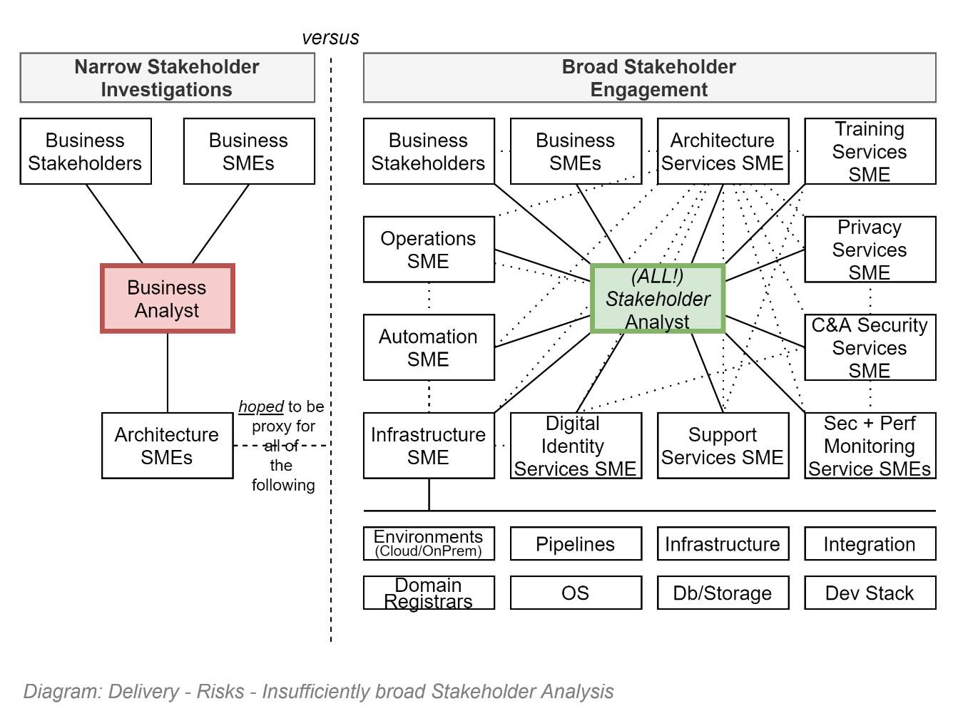

SME as BA
The use of an SME directly for requirements development -- with no unbiased Stakeholder Analyst to broker the conversion of their Desires to Definitions -- is an especially high risk as it provides no built-in check as to whether the requirements are broad across all stakeholders, or across the full-service lifecycle, within and outside of the organisation, while being coherent, correct, or complete.
The risk is that the new project will focus on delivering a variation of a Like for Like outcome whose primary outcome is at best a solution to long standing past problems in existing solutions, rather than thinking afresh to deliver new opportunities.

Business versus Stakeholder Analyst
The hiring of a Business Analyst to capture the Desires of SMEs representing Stakeholders is an improvement – but still has significant risk. A Business Analyst most often concentrates on capturing primarily the Business Stakeholder Requirements – to the exclusion of all the other stakeholders.
Thus setting up a wasteful tension between analysts – representing solely business stakeholder interests – and architects – attempting to represent all the technical stakeholders.
When an Analyst is not investigating all the other stakeholders – who are generally technical stakeholders – it often falls to the architect to stand in as their proxy and provide their requirements. Although most Architects have the experience to do an acceptable fulfilment of this role, they are not Analysts – there are significant risks that Architecture requirements are considered less important than the Business functional requirements. Secondly, there is risk that even if considered, there is incompleteness, or simply discrepancy with other requirements gathered by others.
A Stakeholder Analyst is a better term to use as it defines the role better. An Analyst should be collecting the desires of all stakeholders – business and technical.

Delivery SMEs Roles
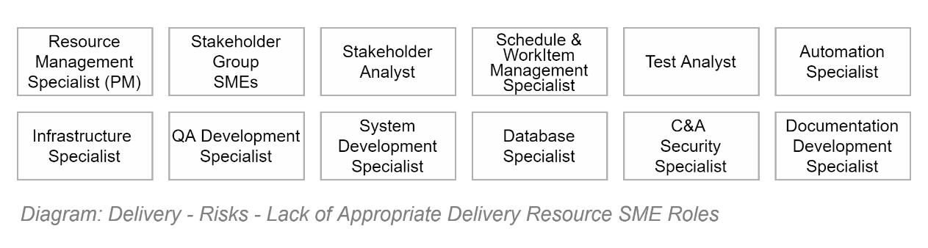
The complexity of expected information services, and the automation systems used to facilitate their delivery require specialist knowledge provided by multiple Subject Matter Expert (SME) roles.

Role allocation in small to medium sized projects
Note that the previous diagram describes Roles – not Identities or Persons. Therefore, the diagram is not meant to imply that all IT projects need that many employees to get going, or even continue.
They are Roles, which – due to lack of capital, availability, capability – you can assign to whomever is capable. It is expected that some Persons will fulfil multiple Roles.
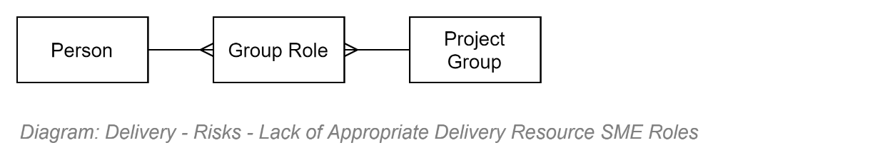

Objective
In IT projects, the primary goal is to transfer the knowledge of SMEs to be automated where and when possible, constraints notwithstanding. The SMEs to automate is not limited to just the Business SMEs.

Methodology
It is a risk to project delivery to believe that software delivery is an immature subject matter that has no methodology.
Contrary to common lore, software system engineering is a mature industry that has been continually developing for the past 80 years. More than the number of years since travelling into space, satellites. In other words, there are well-understood and well-tested ISO standards that provide guidance on how to specify objectives and manage their delivery.
Consider decreasing the risk of not delivering by following the advice, phases, activities and tasks outlined within either ISO-12207 , or the more brief and focused advice within IR0-29110 (specifically ISO-29110-5-1, ISO-29110-4-5, ISO-29110-5-5).

Deliverables
The primary risk to delivering a valued service is focusing on delivering the wrong service.
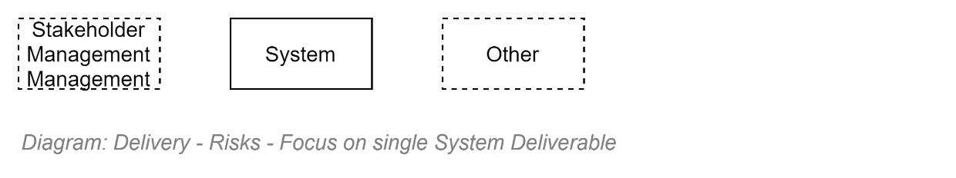

Single Deliverable
Most projects focus almost exclusively on delivering a single Deliverable -- the Business Information Service System itself.
Some effort is allocated to managing business stakeholders.
Anything else is expected to be addressed as they are discovered as needed: Environments, QA artifacts, C&A, Deployment pipelines, Change Management requirements, etc.).
This could not be further from the wider stakeholders’ expectations.

Multiple Deliverables, for distinct stakeholders
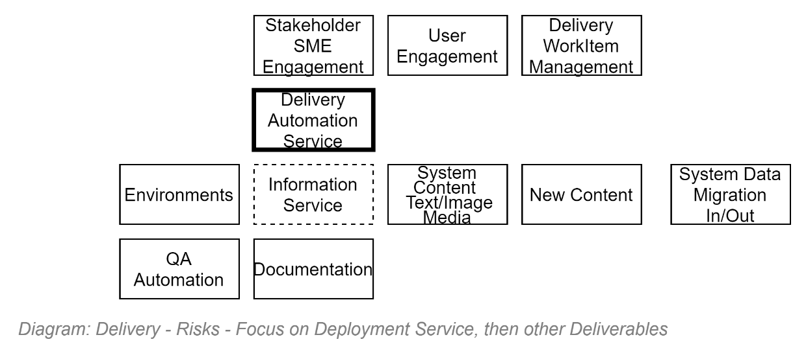
When considering all stakeholders, the list of deliverables expands to address their desires as well.
At the very least, the following will be needed to be delivered to help the initial developers, or those that will be coming after them to use, support, operate & maintain the service.

Environments
Systems can’t be delivered unless there is a place to deliver them to. Hence the need for several distinct Environments: Build Test (BT), Developer Test (DT), System Test (ST), User Test (UT) for handling non-production data, and a Production (PR) environment that is hardened sufficiently to handle Production Data.

Business System Deliverables
There is a risk that planning is applied to the primary business service’s logic, while omitting to plan for the delivery of the following:
- System Media Data: accessible and usable copy & images & possibly even video as required by the system’s Messages and User Interfaces.
- System Content Data: cohesive content (e.g.: about departments, products, courses, learning resources, etc.) required to be in the system before it will be of value to users.
- System Meta-Data: a content and relationships metadata classification ontology (e.g.: tagging, link weights, containers, etc.), including automatic assignment rules, to improve searchability later.
- System Data: the replacement of legacy systems entails also planning how to extract data, address data quality issues, and importing the data into the new system.
- System Groups & Users: new systems – or the Identity Providers (IdPs) they rely on -- may also need to be pre-populated of Users & Groups & Roles before users can use it.
In addition to the above, there are other sub-deliverables required before the system can be presented to users, including:
- QA automation: there is significant commercially risk to releasing systems that damages the organisation’s reputation by being defective, or worse, insecure. QA is required. QA by automation allows for it to be done often.
- Documentation: the system should not go live if it can’t be monitored, maintained, operated, supported, or used by end users. Documentation that iteratively improved is required.
But the most important deliverable is not the Business Information Service.

Key Delivery Service
The deliverable that has the highest value and should be concentrated on most upon is the automation of the delivery itself.
It ensures:
- infrastructure expertise is encoded as automation instructions, addressing initial deployment, required redundancy and potential DR requirements,
- Stakeholder Analysts instructions are encoded as logic,
- the optimisation expertise of database specialists is encoded as schema instructions,
- that QA Analysts tests are encoded as automated tests,
- reports are automated to back documentation for Support, Operations, Maintenance, Backup & Restoration, DR, Integration
- all while linking traceable change effort to work items to both implementing persons and submitted stakeholder desires.
Basically, a key risk mitigation is to understand that focusing solely on the business stakeholder’s desires is a risk that is only mitigatable by enlarging the scope from simply encoding the logic of Business SMEs to all the SMEs that are needed to keep a service functional and improving over its whole service lifecycle.

Requirement Development
A project’s team cannot effectively work together to deliver expected results if the requirements to do so are of low value (incomplete, incorrect, ambiguous, unachievable, unprovable, costly).
The importance of high value obligation statements cannot be overstated.

Requirement Categories
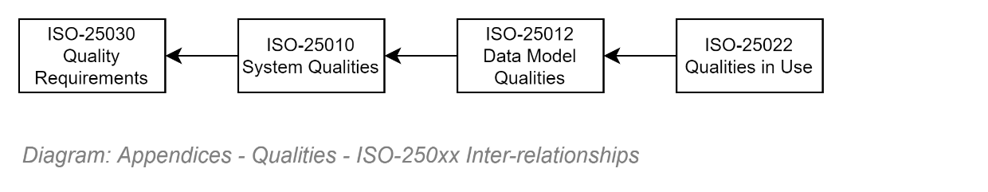
A risk is that the only requirements that get attention are those tied to Business Stakeholder desires, without clear guidance as to what other requirements to consider.
There are well-understood and well-tested ISO standards that provide this guidance.
They fit together as per the diagram below, providing strong guidance on what to investigate, and capture as obligations.
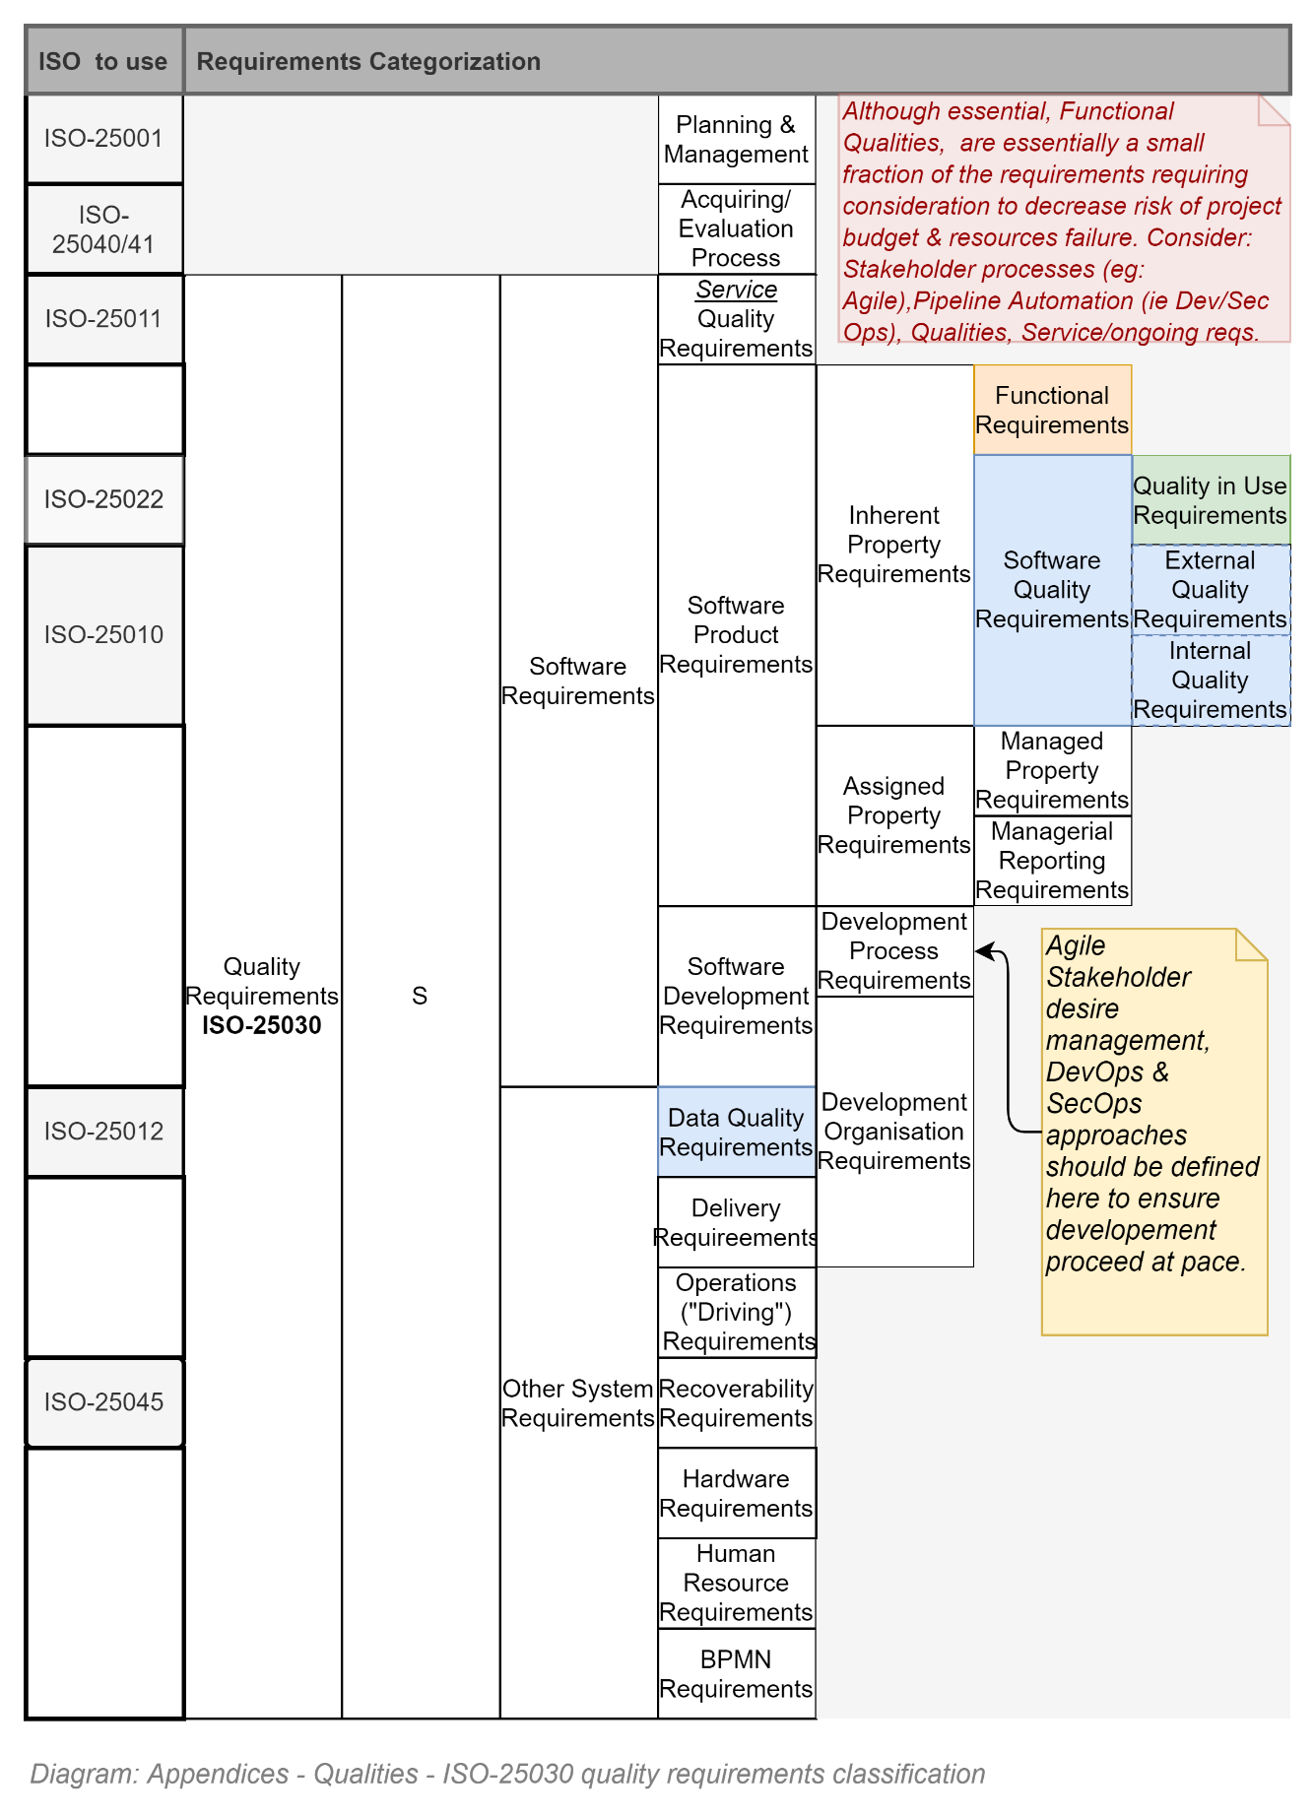

Requirements Attributes
Current practice is to capture user desires as User Stories and using them to drive development.
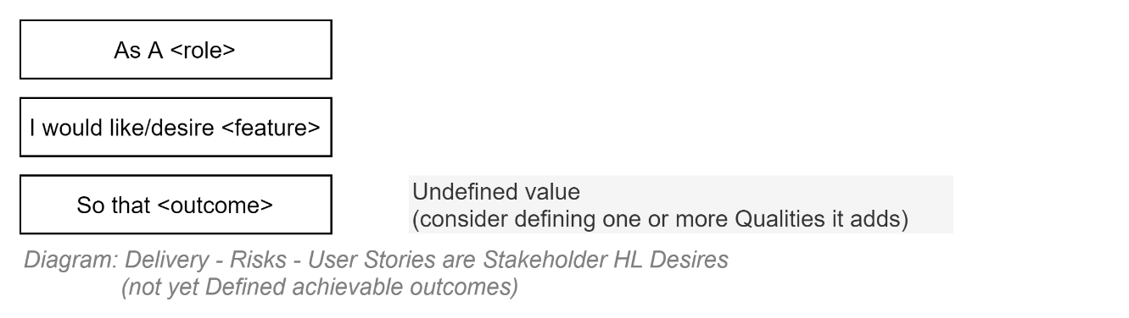
This leads to ambiguity and subsequent delivery risk, as User Stories are not requirements. They are Stakeholder facing Desire statements that require completion by a Stakeholder Analyst with achievable sub-tasks to define the Obligations/Requirements.
Note:
In Agile Projects, obligations are defined as User Story sub-Tasks.
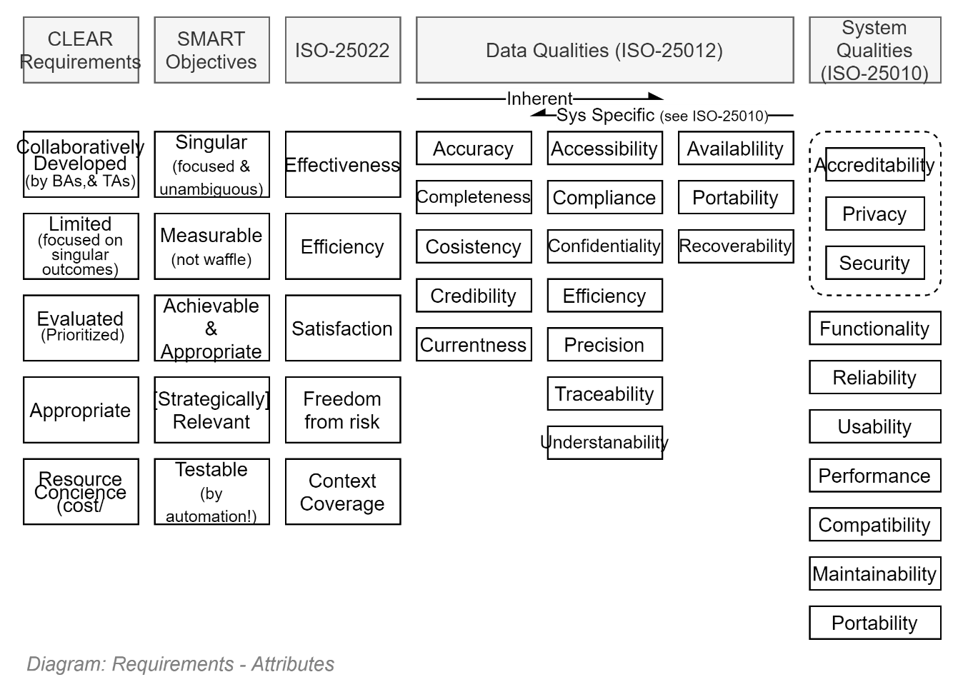
High value delivery Obligations (i.e., Requirements) have specific qualities:
- They are developed in a CLEAR process
- They are developed with SMART attributes
- They specifically aim to deliver one or more Qualities (ISO-25022, ISO-25012, ISO-2010)
- By delivering Functionality
- Which a Stakeholder SME has Championed
- And can be proven to have been delivered by Automation.

SMART Requirements
If nothing else, the greatest mitigation against Stakeholder Analysts developing unclear, ambiguous, unachievable obligation statements that will negatively impact subsequent stakeholders is to ensure that User Story subTasks are SMART.

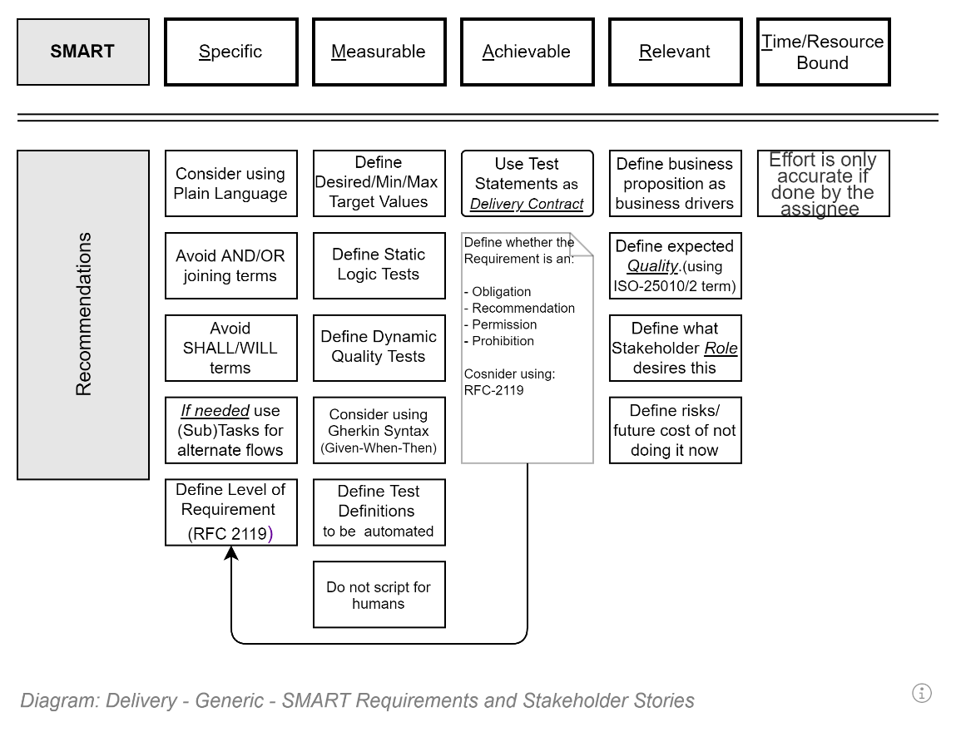

System Design
Risks to project delivery include the choice of wrong design approach and/or the wrong sequence of effort developing the design.
Although Managers are specialists in managing available resources to deliver on expectations and are not expected to be system design specialists, risk can be mitigated by understanding why certain approaches to delivery incur more risk than others, and ensuring that teams avoid some of them.

System Design Types
It is a risk to believe that each system is different, therefore there is little that can be planned or optimised.
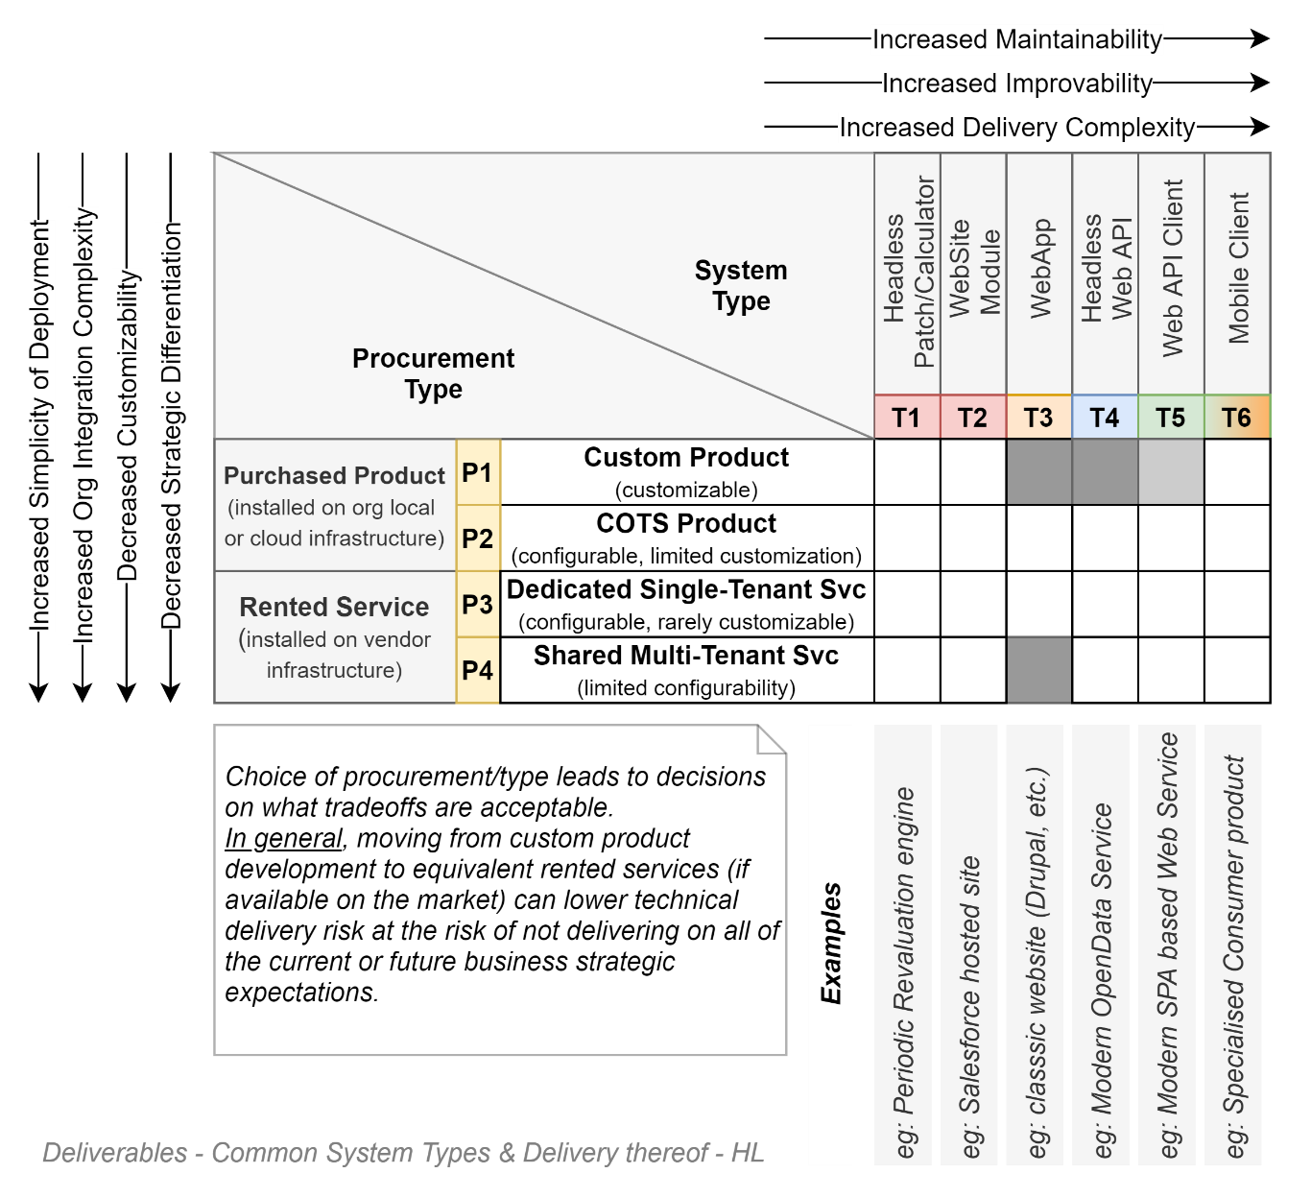
Most enterprise systems conform to well known deployment and design patterns -- as per the above rubric – and of those, most systems conform to only 4 different combinations.
Therefore, if an architecture type is proposed that is either not of these 4 top choices, ensure that due informed specialist consideration has been applied before embarking in that direction.

Basic Architecture Stack
Below is a diagram demonstrating best practice for layering new systems.
The basic pattern is used daily to deliver new systems, and more importantly has been proven repeatedly to be a sound foundation for successfully delivering maintainable services that meet expectations.

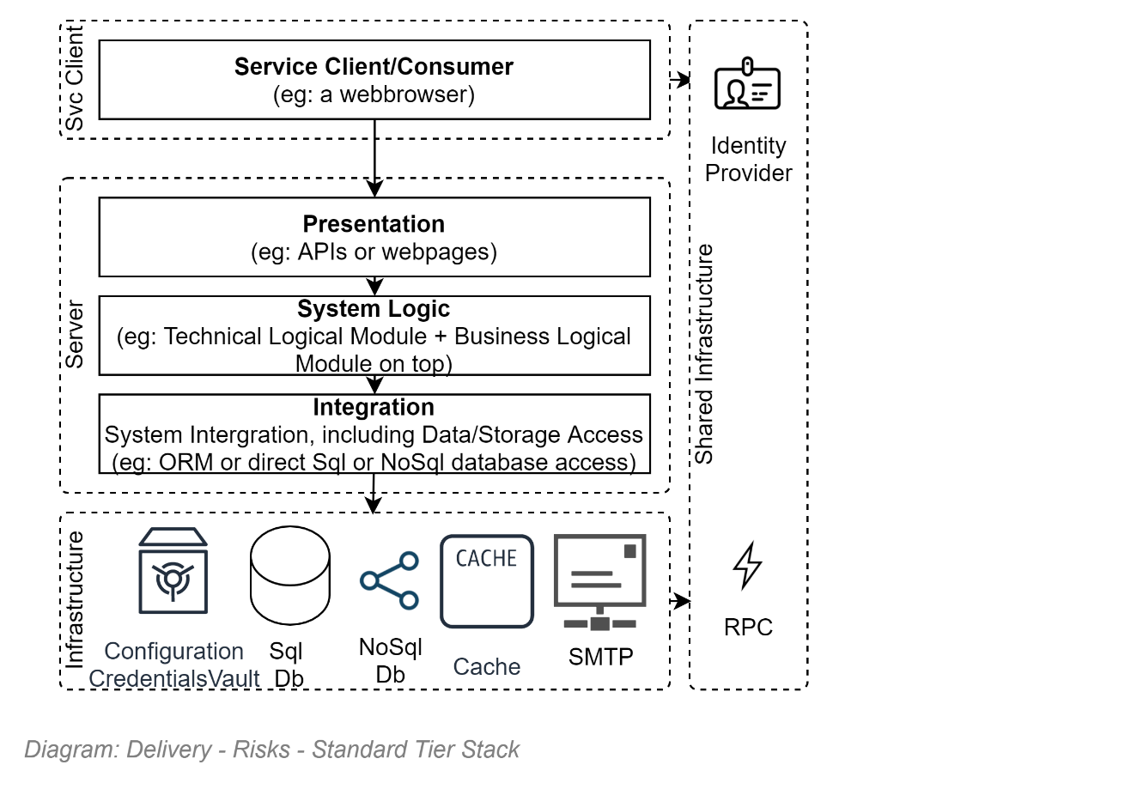
The following directions are sometimes proposed by technical domain specialists, but the advice must be considered carefully against the risks of being atypical.

Database system hosted logic option
Although it can be done, professional Developers have known for a long time that Controllers (a type of class that is used solely in the Presentation layer) are best when kept “thin” and free of System logic.
The same advice is applicable to checking whether logic should be in a database or not.
It can be done. But is most often highly inadvisable:
- Error Prone and costly repetition: Stored Procs must repeat all the validation logic that was (or at least was supposed to be) in the Presentation and System Logic Layers, developed with modern languages and libraries.
- Less capable: Stored Proc languages are specific to data, as opposed to being general, able to take advantages of SaaS APIs, etc.
- Difficult to test: Stored Procs can be tested using SQL DB specific Unit Tests – but their development is difficult compared to testing system logic code,
- Incorrect focus: Testing is focused on testing data, rather than testing logic.
- Inefficient: Stored Proc languages have barely advanced in the last 20 years, as compared to increased libraries and language capabilities that have continually been added over the same period to Java, C#, JavaScript, Typescript, Python.
- Unmaintainable: as organisations rarely develop current solutions using logic in the database layer, the need for in-house Db capable resources is diminishing over time. Organisations may have to rely on expensive consultant specialists to complete changes, no matter how trivial.

Micro-Services Approach
The incorrect use of micro-services adds latency, deployment and development complexity.
Micro-services are nothing more than a mechanism to address dependencies between inter-departmental group development teams.
Separating a service into micro services to Identity, HR, and Business independently of each other is logical.
Separating a service into micro services for sake of it (e.g.: Logging, Workflows, Business Logic, Data Access) when they will be all managed by the same development team is incorrect design. It’s confusing Components with Micro-Services, achieving nothing but adding complexity of the system design, latency, and complicating deployment exponentially.
The following assumes that the standard stack approach is what the project decides to follow.

Logical Ordering of System Component Development
A risk to delivery is to only understand part of the domains involved in delivering an IT service.

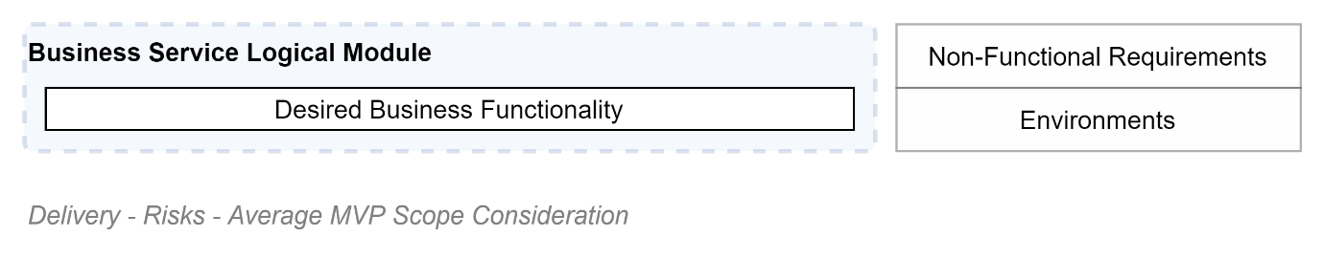
IT service is the marriage of two domains –Business and Technical automation. Knowing just the Business domain is insufficient to deliver a complete system on time, within budget, meeting expectations.
There are two logical domains – therefore two logical domains that require development. Closest to the hardware is the technical domain. Once developed it generally is easy to develop the next logical module – the Business service logical module.
Although systems often have different business needs, the technical logical module’s sub-components are well established. The following is a diagram of the logical modules and their sub-parts required for developing most organisation systems.
The order of the domains, logical modules, components are important and determine the sequencing of effort.
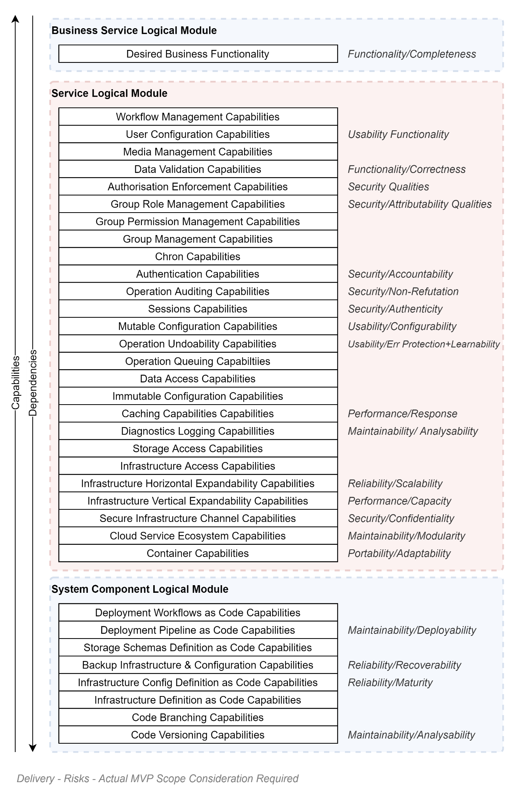

Costly Logical Errors
A risk to project delivery is choosing poor value development patterns that provide initial gains, but later hamstring the ability to precisely model desired stakeholder functionality.
Being plentiful, the logical errors that development stakeholders can introduce are plentiful and so should be treated in a separate document.
But, at a very high-level, common high impact development & design decision errors include:
- “Deliver often. To business stakeholders.”
  - The first part of the statement is correct. The second part is incorrect. It should read “To Stakeholders”. As stakeholders, every stakeholder goup must be addressed.
- “Business stakeholders come first.”
  - Technology stakeholders are a Stakeholder Group like any other. The only difference is that they can make subsequent delivery efficient – so should go first.
- “Security can wait. Business stakeholders come first”:
  - The reputational damage of a breach outweighs any need for immediacy.
  - Security Specialists are a Stakeholder Group like any other. The only difference is that their demands are luckily far less than other groups, and come first. Business stakeholders will have to wait.
- “System Roles will suffice.”
  - Roles are a tool that makes handling Permissions easier to assign to Groups. Neither Groups nor Permissions should be skipped.
- “Developing Reports can be delayed.”
  - Although Paper is an antique technology, printed Reports are in some ways the most important User Interface – viewable by Stakeholders who make decisions as to the value and fate of the system and project. With effective design, Paper reports can reuse screen development effort, keeping report development costs down.
- “The use of ORMs slow requests down, so should be avoided.”
  - Considering the ability of most developers and penetration report statistics, there is far more risk in believing them capable of developing efficient SQL without introducing Sql Injection or other attack vectors. Bet on ORMs for delivery speed while not adding security risks, and optimise with Caching and/or Db schema optimisation later.”
- “Cache is not needed”
  - Caching is a fundamental element of IT software design and should be one of the first integrations hooked up for use at all levels, whenever appropriate. It’s expensive to add in later.

Effort Estimations
A risk of not meeting deadlines is the underestimation of effort required to accomplish tasks to meet deadlines.
With development team resources assembled for each project there is no definite certainty of capability or speed of a team’s output. But there are ways to improve estimating.
The first is to provide higher value requirements, with discrete, achievable tasks. Developers can estimate quite well precise requirements.
The second is to collect and make available data for developers to compare their previous estimates to actual durations, to inform their next estimates. And for managers to compensate for their estimates if they remain constantly imprecise.

Delivery Team Interactions
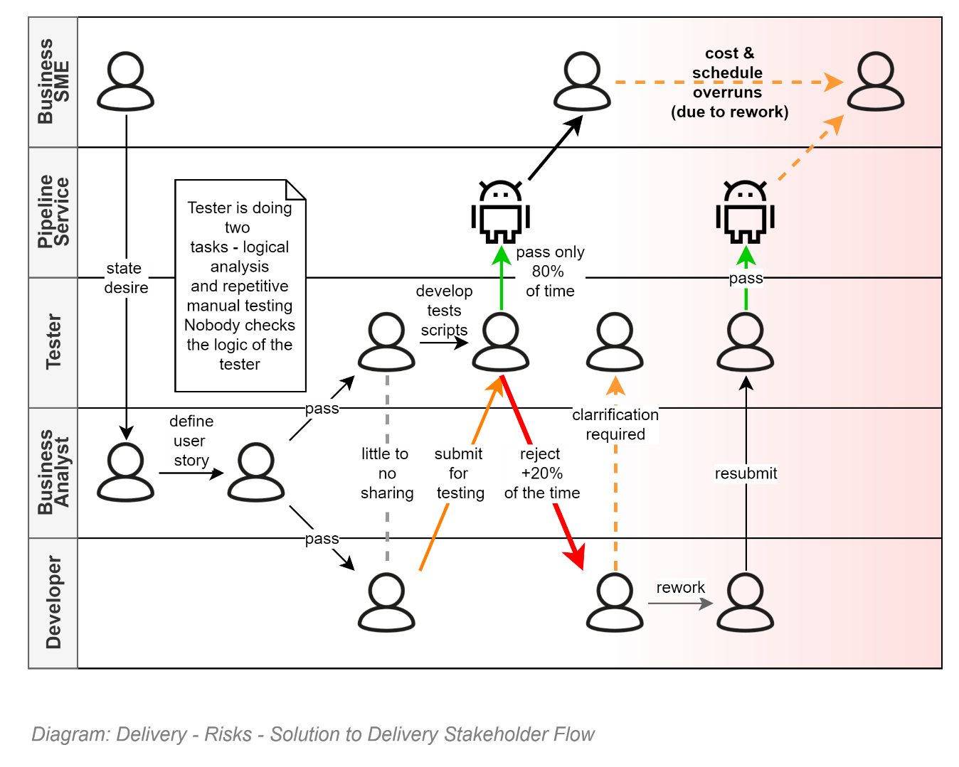
A key risk to successful timely project delivery that meets expectations is the expense and time required to relitigate & rework issues.
A leading cause of unanticipated misunderstanding, delay and rework is a by-product of the development workflows used in many projects. Specifically: the interaction between Developer resources and Tester resources.
Note:
The workflow is a legacy of manual testing days, when Testers did both Analysis and Manual Testing, with or without tools.
The issue is because User Stories are not intended for Development – they’re primarily intended for understandability, confirmation and sign off by Business and other SME Stakeholders.
In a perfect world, these statements of Desires would be singular in scope, and most importantly, unambiguous. English is a flexible language, that can be used to economically insinuate meaning – although at the expense of clarity and unambiguity.
This means that if the same User Story is presented to two different stakeholders – such as a Developer and a Tester – with varying ability to understand English – for example if it isn’t the primary language of both persons – then the chance of both understanding the same terse User Story the same way is not 100%.
In fact, many IT reports estimate that – aside from unintentional coding errors -- the difference in understanding is generally anywhere between 20% and 37%.
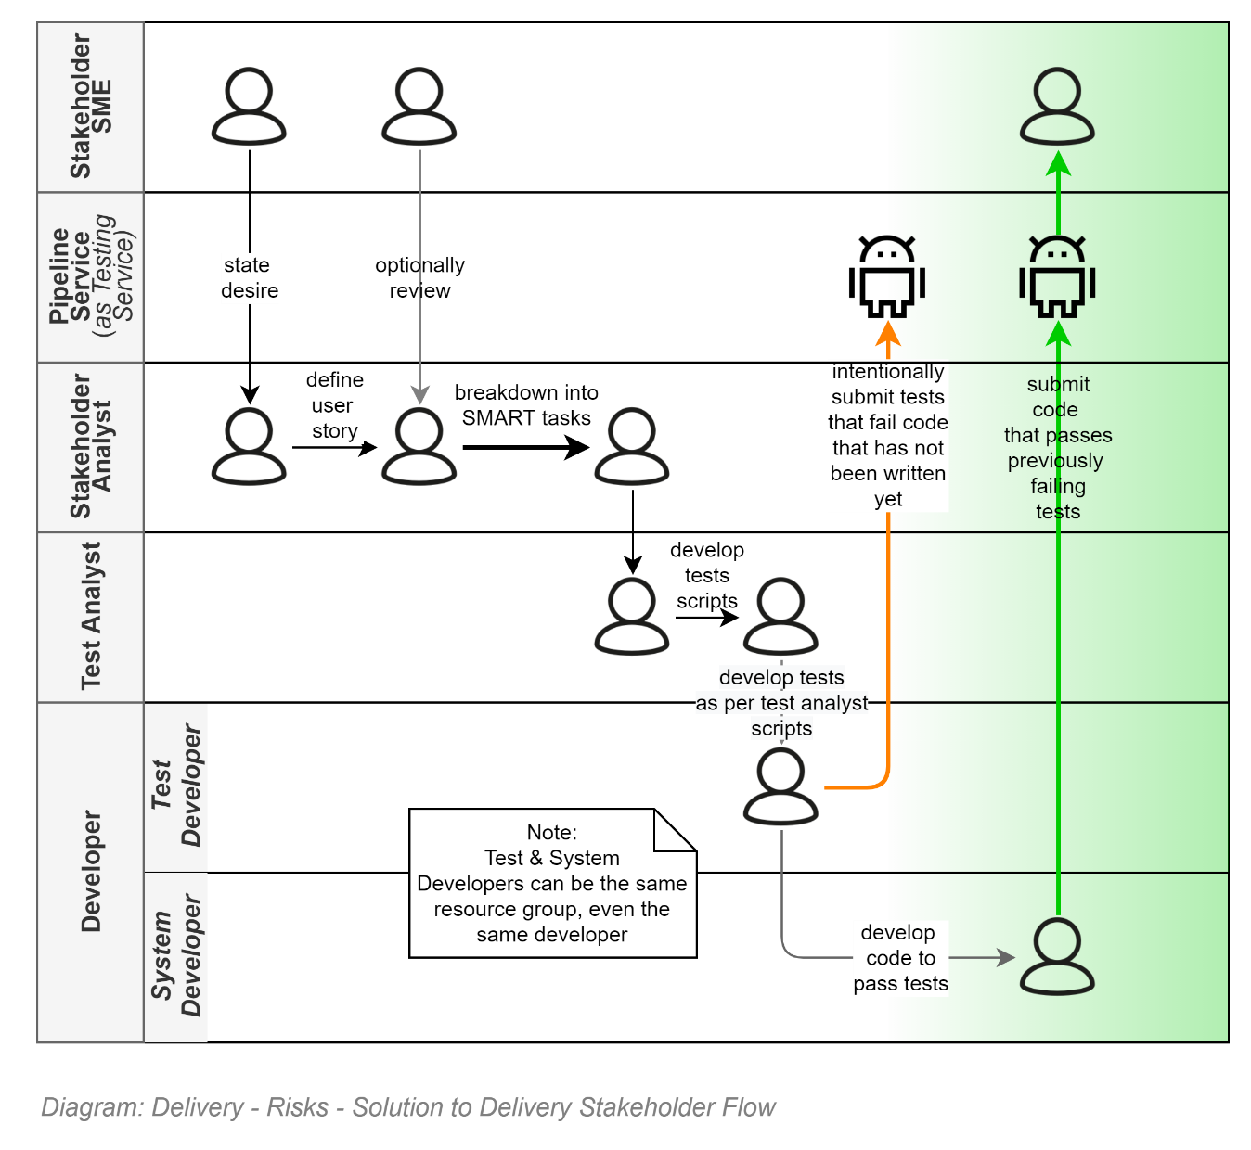
An accepted best practice to mitigate the above issue as follows:
- Stakeholder Analysts work with SMEs to craft an acceptable User Stories.
- Stakeholder Analysts work alone to break the User Story down into discrete SMART tasks.
- Test Analysts work to develop one or more automatable GWT statements to associate to each task.
- A Test Developer works to convert the humanly readable GWT statement into automation code and submits the work into a work item specific branch of the code base.
- The new tests will fail that code branch.
- A System Developer picks up the work item, ignores the User Story text (as it wasn’t really for them in the first place), and works to meeting the Automated Tests until the user story specific branch passes the tests.
The rework effort drops to a low 1 to 2% percent, generally attributable to poorly defined or implemented automated tests.
Note:
In essence, the development effort is changed from a faulty, conflicting “parallel” processing approach to a “serial” processing approach.

Defect Catching
The diagram below illustrates the impact on delivery schedules that catching bugs late adds.

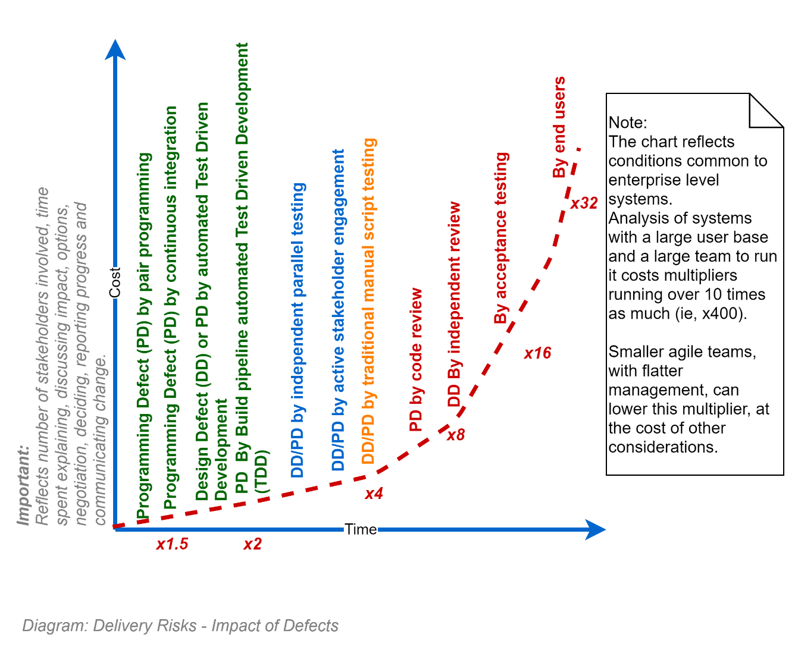
The chart backs the recommendations given elsewhere that:
- User stories are broken down into discrete tests
- Delivery team interactions are optimised to reduce disagreement as to user stories intent
- Test automation be used in pipelines as soon as possible

Full Regression Testing
It doesn’t matter how much you optimise the efficiency and correctness of development effort – if one can’t get rid of the risk that it can’t be let out the door without a long delay.
A clear benefit of the previously described approach to development/testing interaction is the certainty that almost 100% of the work items will be backed by automated testing, removing the need for the long, arduous and expensive full-regression tests that are so endemic on poorly optimised projects.

Capabilities
Finally, it goes without saying that the risk of project delivery failure is directly affected by the team’s capabilities to cover all required roles to deliver all required deliverables to complete all expected requirements to address stakeholder desires & expectations.

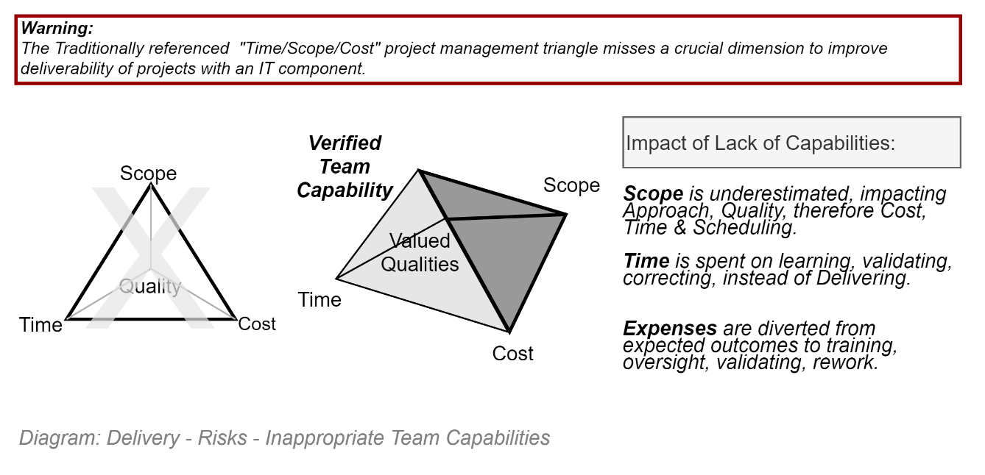
The risk can be mitigated by putting effort into testing the capabilities of team members as individuals and their ability to contribute to the abilities of the team as a whole. The two are distinct.
The adage “Smart, gets things Done” remains a valuable synopsis of criteria to seek, although I might recommend extending it as follows:
“Smart, Contributes & Gets Things Done, without Excuses or Disruption”.

Conclusion
A quote to consider as being relevant:
“Adventure is just poor planning.” Is attributed to Roald Amundsen, who got to the South Pole first. Robert Falcon Scott, tragically, didn’t. The difference between the two outcomes can be largely attributes to Roald focusing on getting back alive– the full circuit -- whereas Scott focused on getting to the pole.
The difference between the two approaches has a lot in common to the difference between planning MVSs and planning only to get to the Go-Live of an MVP.
Good luck.

Appendices

Glossary

CAPEX
Capital Expenditure are expenses on the purchasing of configuration and/or customisation of a COTS or custom Assets that will subsequently gain value or devaluate over time. See OPEX.
Note:
a common complaint of the separation CAPEX & OPEX is that it applies forces on Delivery stakeholders to maximize development time (therefore associated costs) to increase the value as much as possible before it begins an extended period of devaluation. See OPEX.

COTS
Commercial off the Shelf: ready-made, possibly configurable, purchasable service system components or whole products or services, that avoid the effort, expense and risk of custom development.

Go-Live Deployment Lifetime
A natural consequence of CAPEX/OPEX separation, it is the duration of time to only includes the processes required to meet to an initial go-live date.

IdP
Identity [token] Provider Services manage user credentials (email + password, biometrics, etc.) and upon confirmation by a user, return an IdP issued identity token that information systems trust sufficiently to in turn issue System issued user tokens.

MVP
Minimum Viable Product is often simply the minimum acceptable functionality that business stakeholders will sign off on, as the result of a CAPEX funded development effort.

MVP
Missing Valuable Planning: the product that is delivered when Agile patterns are incorrectly applied.

MVS
Minimal Viable Service: the service with the minimum acceptable functionality that stakeholders will sign off on for the first delivery of many over the service’s lifecycle.

OPEX
Operational Expenditure is the spending on keeping delivered products and services meeting contractual obligations.
Note:
a common complaint of the separation CAPEX & OPEX is that it applies forces on stakeholders to limit expenses, therefore improvements, to the bare minimum as CAPEX effort is not accounted as enhancing the value product. See CAPEX.

OIA Request
Official Information Act Request is a request from the public for information on accountability of decisions, actions, communications ensuing expenses -- after PII has been extracted from the report. See PII.

PII
Privacy Impacting Information is information that can be used to identify a person. Examples include, but are not limited to, combinations of some or all the following: given name, surname, aliases, DOB, education cohort, organisation group, contact channel information, national service identity numbers.

Service Lifetime
The duration of time that includes a service’s iterative phases – which include initial delivery organisation, discovery, definition, development, documentation, deployment, driving (operating & maintaining & supporting & measuring), decommissioning. See Go-Live Deployment Lifetime.

SME
Subject Matter Experts are persons with the role of being the go-to person with the most applicable expertise in any given subject. In IT projects the Subjects required will inquire the Business subject itself, but also work item & delivery organisation and automation, deployment automation, infrastructure automation, database schema definition automation, logic automation, presentation, security, privacy, legal, accessibility, usability, user interface design.

Work Item
A delivery task. In an Agile environment, or any of its subsets (including DevOps & SecOps), a Task is publicly published on the Kanban (work item board) as an Epic, Feature or Story (and potentially its sub-Tasks) depending on the scope & size of the task.

YAGNI
“You ain’t gonna’ need it” is well-known and often quoted industry design principle.
Note:
Although oft quoted by developers, it is often quoted without understanding that it is Design Principle – not a Development Principle. In other words, it doesn’t negate careful consideration and Design before beginning Development.

Note that the legacy term “Non-Functional Requirements” certainly doesn’t help convey their primary importance.
The only part of software development that remains difficult is the artistic side, trying to commercially attract fickle human emotions – and dealing with the results of the industry’s continually lowering of the bar of entry.
For expediency’s sake, and in accordance with Agile YAGNI development principles, some parts can be omitted (or at least developed in a limited manner) till a definite need has been proven for them. Note that, there are not many that can be omitted entirely and won’t be needed by the end of the project.
And the 80% success rate is only achievable under first-language conditions.

